1. Locating on the basis of class

element(by.css(‘. classname’))

Here, ‘.’ (Dot) means that preceding text after dot is class name



1. Locating on the basis of id : ‘#’ can be used



1. CSS chaining





1. Child elements

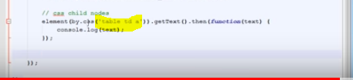

1. On the basis of attributes

